

**Project Document**

**Name :R.T.Gokullashre**

**Register Number :720722110009**

**Department :B.Tech IT**

**Year :2nd Year**

**Project Title**

Design Thinking In Chatgpt

**Template Name**

TO DO LIST

**Problem Statement**

**A to-do list in the software industry serves as a dynamic checklist for organizing tasks, prioritizing work, and tracking progress within projects. It aids teams in staying focused, ensuring deadlines are met, and fostering collaboration by providing a clear roadmap for development cycles.**

**Project description**

**"TaskMaster" is a dynamic task management application designed to streamline productivity and organization for individuals and teams. With TaskMaster, users can create, prioritize, and track tasks effortlessly, ensuring nothing falls through the cracks. The intuitive interface allows for easy categorization of tasks, setting due dates, and assigning responsibilities, facilitating seamless collaboration among team members. Additionally, TaskMaster offers customizable features such as recurring tasks, subtasks, and reminders, empowering users to tailor their to-do lists to their unique workflows. Whether you're a busy professional juggling multiple projects or a team leader coordinating complex assignments, TaskMaster provides the tools you need to stay on top of your tasks and achieve your goals efficiently. Say goodbye to scattered sticky notes and disjointed emails – with TaskMaster, managing your to-do list has never been easier.**

**\*\*Introduction:\*\***

**TaskMaster is a comprehensive task management application designed to enhance productivity and organization for both individuals and teams.**

**\*\*Features:\*\***

**1. **Task Creation:** Users can easily create new tasks, specifying details such as title, description, due date, and priority level.**

**2. **Task Prioritization:** Tasks can be prioritized based on urgency and importance, ensuring that users focus on the most critical assignments first.**

**3. **Task Tracking:** The application allows users to track the progress of their tasks, providing visibility into which tasks are pending, in progress, or completed.**

**4. **Collaboration Tools:** TaskMaster facilitates seamless collaboration among team members by enabling task assignment, comments, and file attachments.**

**5. **Customization Options:** Users have the flexibility to customize their to-do lists with features such as recurring tasks, subtasks, and reminders, catering to their specific workflow needs.**

**\*\*Benefits:\*\***

**1. **Enhanced Productivity:** TaskMaster helps users prioritize their tasks and stay focused on what matters most, resulting in improved productivity and efficiency.**

**2. **Improved Organization:** With TaskMaster, users can keep all their tasks centralized in one place, eliminating the need for scattered notes and reminders.**

**3. **Effective Team Collaboration:** The application fosters collaboration among team members, facilitating communication and coordination on shared projects.**

**4. **Flexible Workflow:** TaskMaster's customizable features adapt to users' unique workflows, ensuring a seamless and personalized task management experience.**

**\*\*Conclusion:\*\***

**TaskMaster revolutionizes task management by providing a user-friendly platform with robust features tailored to meet the needs of modern professionals and teams. Say goodbye to the chaos of managing tasks and hello to streamlined productivity with TaskMaster.**

**Worked Template with explanation**

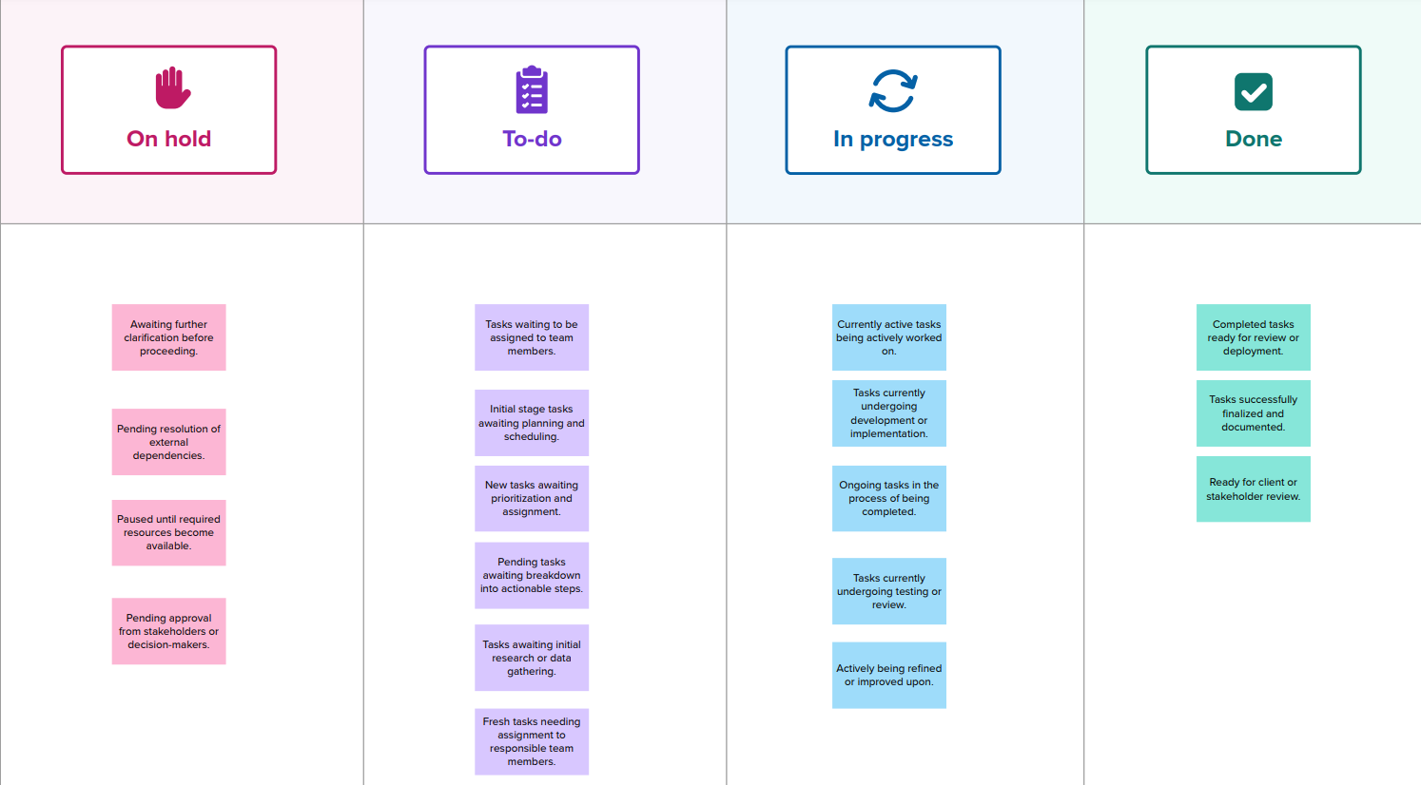

**A to-do list is a simple yet powerful tool for organizing tasks and managing time effectively. It starts with jotting down all pending tasks, whether personal or professional, into a centralized list. Next, tasks are prioritized based on urgency, importance, or deadlines. This prioritization helps in focusing on the most critical tasks first, ensuring they get completed on time. As tasks are completed, they are checked off or marked as done, providing a sense of accomplishment and progress. Additionally, to-do lists often include features like setting reminders, categorizing tasks into different projects or categories, and breaking down larger tasks into smaller, manageable subtasks. Regular review and updates of the to-do list help in staying on track and adapting to changing priorities. Ultimately, a well-maintained to-do list serves as a roadmap for daily activities, enhancing productivity, reducing stress, and fostering a sense of control over one's workload.**

**GitHub Link:**